# REAL ESTATE MANAGEMENT DATABASE SYSTEM

# (REMDBS)

# Final Report

Sai Vaishnavi Govindula (Team Coordinator)

Jyotheeswar Mandala

Sandeep Damodharreddy

Kalyan Chakravarthy Paleti

# PART A

## Description/Scope:

The Real Estate administration Database System (REMDBS) aims to make property administration and associated tasks easier for real estate agents, property management companies, and individual property owners. The primary objectives of REMDBS include the following:

Efficient Property Management: Make it easier to add, update, and remove properties, and group them into categories based on different criteria to make searching and filtering simple.

Good Client Management: Maintain contact information, oversee client preferences and needs, and monitor interactions with clients by giving tools for doing so.

Management of Rental Agreements: Streamline the process of creating, managing, and monitoring rental agreements. This includes handling deposit transactions, generating lease documents, managing rental payments, and documenting terms and conditions.

Simplified Property Maintenance: Assist maintenance workers with planning and managing property care, allocating jobs, and keeping correct maintenance records for each property.

Precise Financial Management: Keep track of all real estate-related financial activities, including bills, expenses, and payments. Comprehensive Reporting and Analysis: Create customised reports that include client activities, financial summaries, property listings, and performance indicators to get insight into the real estate sector's operations.

The scope of applications for REMDBS includes brokerage firms, appraisers, inspectors, attorneys, facility managers, developers, investors in multiple properties, certified real estate management companies, and individual property owners. It also covers a comprehensive solution for real estate property and transaction management across various industry sectors. In order to improve operational effectiveness and stakeholder communication, it automates procedures such property listing, client management, rental agreements, proposals, auctioning, property maintenance, transaction financials, and reporting. With its capacities for data modelling, storage, integrity, security, retrieval, and integration, REMDBS seeks to maximise operations, minimise risks, adhere to laws, and optimise returns.

## User Requirements:

1. Authentication and Account Management: Using distinct usernames and encrypted passwords, users should be able to safely log into the REMDBS system. Administrators should be able to add, amend, and remove user accounts, as well as give the appropriate responsibilities and permissions.
2. Role-Based Access Control: The system should allow users to only access information and functionality relevant to their duties. Administrators require comprehensive access to all system capabilities, whilst agents may only be able to view property listings and client management.
3. System Change Audit Trail: All system modifications and administrative actions should be monitored and recorded for security and accountability. To do so, information concerning the alteration, such as the sort of change made, the day and time it was executed, and the offender, must be documented.
4. Monitoring Agent Assignment: The system should make it easy to allocate agents to customers or properties and track who manages which. This function ensures that jobs and responsibilities are equitably dispersed throughout the company.
5. Appointment Scheduling and Calendar Integration: Allow users to schedule meetings between agents and clients. Users can easily monitor and manage appointments owing to the interface with calendar software, which improves scheduling and management productivity.
6. Management of Client Details: Users must be able to keep and manage a wide range of client data, such as names, contact details, and preferences. This feature makes it easier to provide clients with customised services and personalised communication.
7. Tracking Client Preferences for Properties: The system should enable users to keep tabs on client preferences for properties, including size, location, and price range. Agents can more successfully match customers with suitable homes with the use of this information.
8. Tracking Communication History: All correspondence between customers and representatives should be able to be tracked and kept up to date by users inside the system. By giving users access to historical exchanges, this feature maintains consistency and continuity in client relationships.
9. Property Feedback Management: The system should let customers provide comments or suggestions about homes they've looked at. Agents may better understand customer preferences and their property offerings by using this feedback.
10. Internal Agent Communication: Agents have to be able to exchange notes and messages with one another as well as with other agents inside the system. This feature encourages team members to work together and share knowledge.
11. Notification Management: The system should enable users to send and receive alerts, informing them of forthcoming appointments, newly listed properties, and customer queries, among other significant occurrences.
12. Notification Customisation Options: Users should be able to modify their notification preferences, specifying the alert types and preferred delivery methods (such as in-app, email, or SMS messages). This customisation will ensure that users always receive important information on time.
13. Property Listing Management: The system should enable users to add, amend, and remove real estate listings. By allowing customers to maintain accurate and up-to-date property listings, this tool raises the standard of overall client service.
14. Property Search and Filtering: The system ought to include strong search and filtering features that enable users to look for homes fast and effectively based on a range of factors, including amenities, size, price, and location. This feature improves the user experience and makes it easier for customers to identify homes that fit them.

## Business Rules:

1. Only authorized admins can add, update, or remove admin users.
2. Authentication credentials must be encrypted for secure login.
3. System modifications and admin actions must be logged in an audit trail.
4. Agents must have unique names and contact information.
5. Agents can be assigned to clients or properties.
6. Performance metrics for agents must be tracked.
7. Appointments must be scheduled accurately.
8. Reminder notifications must be automatically sent before appointments.
9. Client details must be comprehensive and up-to-date.
10. Client preferences for properties must be tracked.
11. Communication history between clients and representatives must be logged.
12. Feedback on properties must be recorded accurately.
13. Agents can exchange messages and memos internally.
14. Notifications must be managed efficiently.
15. Users should have customization options for notifications.
16. Property details must be complete and accurate.
17. Real estate listings must be managed effectively.

## Entity-Relationship Diagram (ERD)

1. TBLADMIN to TBLAGENT: This link allows several agents to be handled by a single administrator. Because an admin can oversee numerous agents, but each agent is only allocated to one administrator, the relationship is one-to-many (1:M).
2. TBLAGENT to TBLAPPOINTMENT: Enables an agent to schedule several meetings. Since one agent may set up appointments for several customers, but only one agent is assigned to each appointment, the link is one-to-many (1:M)
3. TBLAGENT to TBLCOMMENT: This connection indicates that an agent may get many comments on properties. It's a one-to-many (1:M) connection since an agent can get feedback from several customers, but each remark is assigned to only one agent.
4. TBLCLIENT to TBLAPPOINTMENT: This connection implies that a single customer may have several appointments. It is a one-to-many (1:M) connection since a customer can arrange appointments for numerous properties or meetings with several agents, but each appointment is made by only one client.
5. TBLCLIENT to TBLCOMMENT: This connection indicates that a single client can make many comments on properties. A client can offer feedback on numerous properties, but only one client makes each remark, resulting in a one-to-many (1:M) connection.
6. TBLCLIENT to TBLNOTIFICATION: This connection allows customers to receive multiple notifications. A client can receive notifications of multiple events or changes, but each notice is only sent to one client, making it a one-to-many (1:M) connection.
7. TBLPROPERTY to TBLAPPOINTMENT: It is possible to book many appointments for a single property using this link. It is a one-to-many (1:M) link since a property can be seen by several consumers or scheduled for appointments with various agents, but each appointment is only for one property.
8. TBLPROPERTY to TBLCOMMENT: This relationship shows that a single property may receive many comments. It is a one-to-many (1:M) connection because several clients can assess or response on a property, but each comment has no connection with one property.
9. TBLPROPERTY to TBLPROPERTYIMAGE: This connection indicates that a single property may have numerous pictures. It's a one-to-many (1:M) connection since a property might contain several photos displaying different viewpoints or characteristics, but each image is linked to only one property.
10. TBLPROPERTY to TBLPROPERTYTYPE: The membership of a property in a certain property category is displayed by this connection. There is a one-to-one (1:1) link since every property belongs to a single property type and every property type is related to many properties.

## Data Dictionary

The Data Dictionary describes the structure and connections of a database schema created for a real estate firm or property management system. It is made up of multiple tables, each with a distinct role in controlling different areas of the business operations.   
To begin, the "Tbladmin" table stores information on administrative users, such as their unique identity (AdminID), username, encrypted password for safe login, and role in the system. This table simplifies the management and verification of administrative workers.  
Secondly, the "Tblagent" table contains details regarding agents working within the agency. It includes fields such as AgentID (unique identifier), Name, ContactInfo, and PerformanceMetrics, providing essential information about each agent's identity, contact details, and performance metrics.

The "Tblappointment" table is used to track appointments made between clients and agents. It includes AppointmentID as a unique identifier, along with ClientID and AgentID as foreign keys referencing client and agent details respectively. Additionally, it stores the date, time, and a boolean field indicating whether a reminder notification has been sent for the appointment.

For client-related information, the "Tblclient" table stores details about clients engaging with the agency. It includes fields such as ClientID (unique identifier), Name, ContactInfo, and Preferences, which capture essential information about clients and their property preferences.

The "Tblcomment" table facilitates communication between clients and agents by storing feedback or comments provided by clients. It includes a unique CommentID, along with foreign keys referencing PropertyID and AgentID to associate comments with specific properties and agents respectively.

Furthermore, the "Tblnotification" table manages notifications sent to users within the system. It includes fields like NotificationID (unique identifier), UserID (referencing user details), Type, and Content, allowing for the storage and management of various types of notifications.

The "Tblproperty" table contains information about properties listed by the agency. It includes details such as PropertyID (unique identifier), TypeID (referencing property type), Address, Price, and Size, providing crucial data about properties including their characteristics and pricing.

Additionally, the "Tblpropertyimage" table stores images associated with properties. It includes ImageID (unique identifier), PropertyID (referencing property details), and Image (BLOB), allowing for the storage and retrieval of property images.

Lastly, the "Tblpropertytype" table serves as a reference for different types of properties. It includes TypeID (unique identifier) and TypeName, providing a standardized list of property types used within the system. Overall, this database schema effectively manages various aspects of real estate operations, including user management, appointments, property listings, client interactions, and notifications.

# PART B

## Database Implementation and Demonstration

## Entity Generation and Data Entry

## Tbladmin Table

In the Real Estate Management Database System (REMDBS), administrator information is stored in the "Tbladmin" table.

* AdminID: Created automatically with AUTO_INCREMENT, this is a special ID for every admin user.
* Username: This is the admin user's username, which enables them to access the system.
* Password: For secure login, the admin user's encrypted password is stored in this field.
* Role: This determines the admin user's level of access and rights within the system by indicating the role that has been allocated to them, such as Manager or Administrator.   
  With each item in this table representing an admin user, authorised people may effectively manage and administer REMDBS thanks to the encrypted password, assigned role, and username.

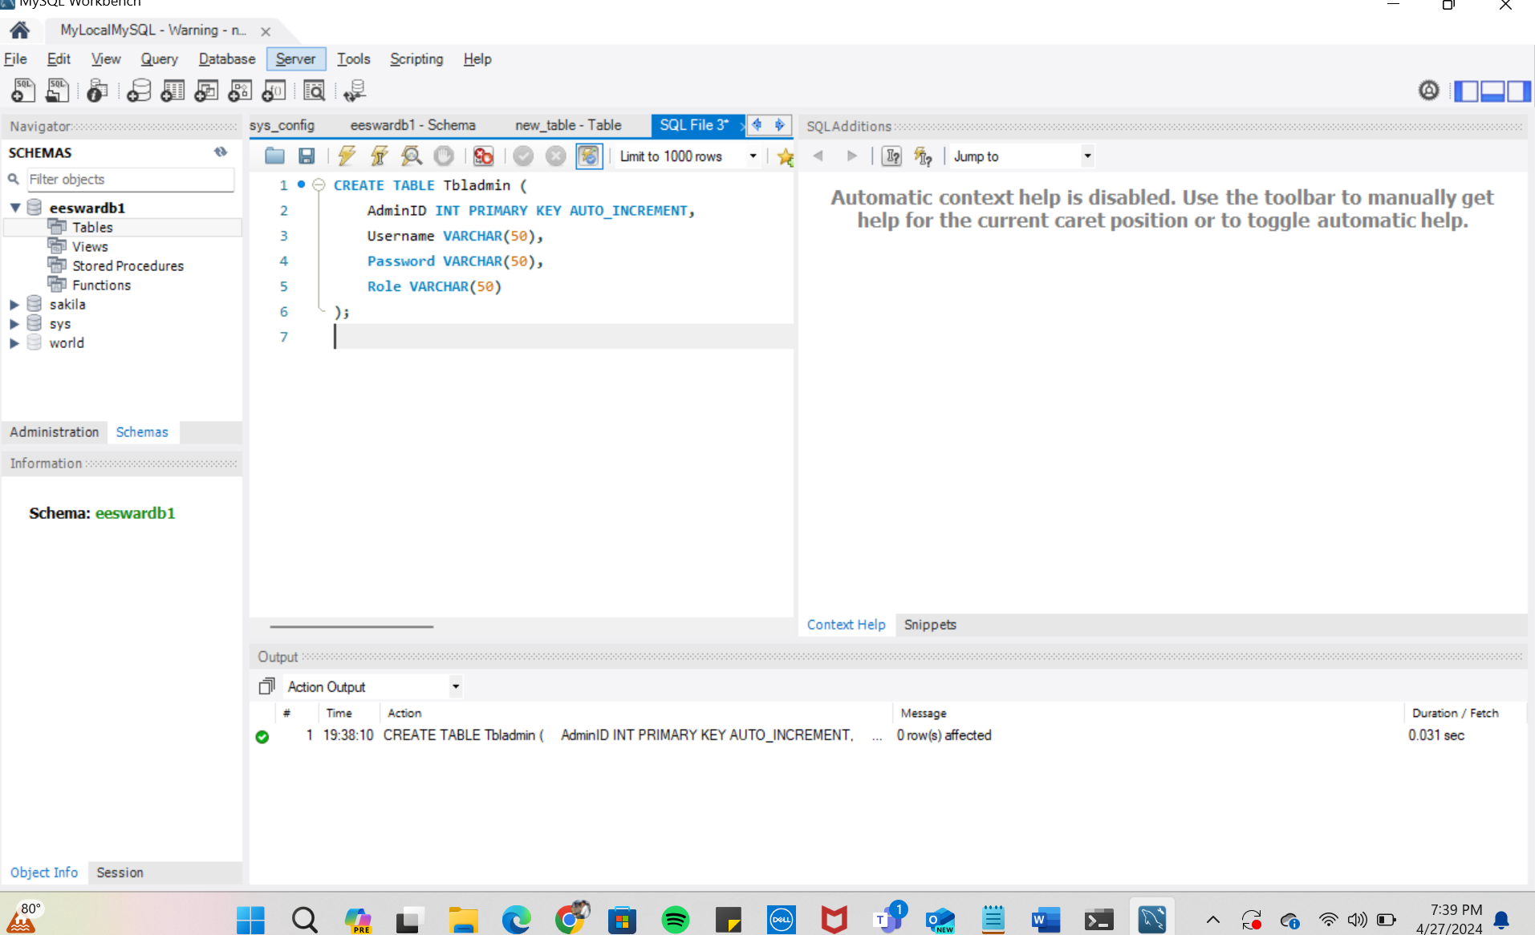

## Tblagent Table

The Real Estate Management Database System (REMDBS) contains information about agents that are involved in transactions and property management in the "Tblagent" table.

* AgentID: This field is automatically increased for every new entry and acts as a unique identification for each agent.
* Name: By storing the agent's name, it makes identification and communication easier.
* ContactInfo: The agent's contact details, usually an email address, are stored in this section for correspondence needs.
* PerformanceMetrics: This is an indication of the agent's efficacy and efficiency in real estate transactions. It shows the agent's performance metrics.

A unique agent is represented by each record in this table, which includes the agent's name, contact details, and performance data. This data is used to monitor agent performance, support agent-to-agent communication, and assess agent contributions to the REMDBS ecosystem.

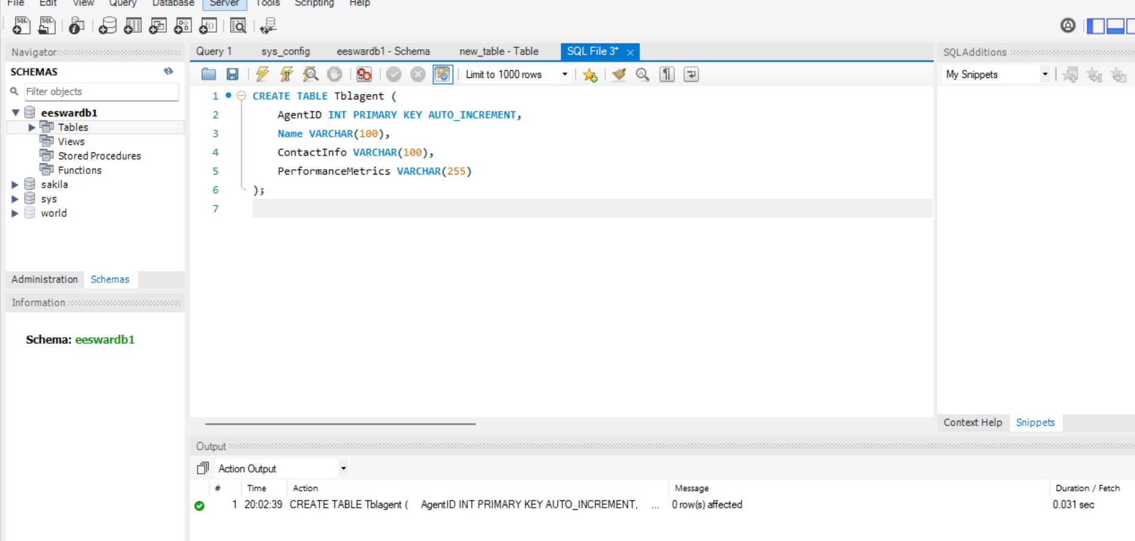

1. **Tblclient Table**

* Client data for property management and transaction activities is kept in the

REMDBS database's "Tblclient" table.

* ClientID: This field is automatically increased with each new entry and serves as distinct identification for each client.
* Name: By storing the client's name, it makes identification and conversation easier.
* ContactInfo: The client's contact details, usually an email address, are contained in this section for correspondence needs.
* Preferences: This indicates the client's preferences with respect to properties, offering information on their favoured locations and types of properties (residential or commercial).   
  Each entry in this table represents a distinct client, complete with name, contact details, and preferences for properties. This data helps with property suggestion and transaction processing, client relationship management, and understanding client preferences.

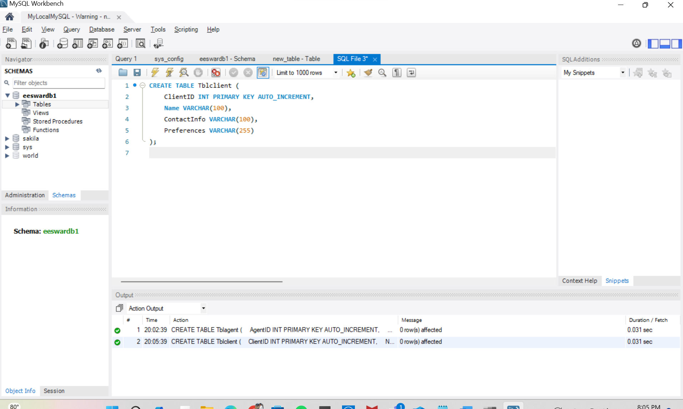

1. **Tblappointment Table**

The REMDBS database maintains a record of appointments made between clients and agents who handle transactions and property management under the "Tblappointment" table.

* AppointmentID: An automatically incrementing unique identification for every appointment.
* ClientID: A foreign key that links to the ClientID in the Tblclient database and refers to the client that is participating in the appointment.
* AgentID: A foreign key that links to the AgentID in the Tblagent database and references the agent that is involved in the appointment.
* Date: The appointment date.
* Time: The scheduled appointment time.
* ReminderSent: A boolean value that indicates if an appointment reminder has been issued.

This table makes it easier for clients and agents to arrange and manage appointments, facilitating effective planning, monitoring, and communication about tasks connected to the property.

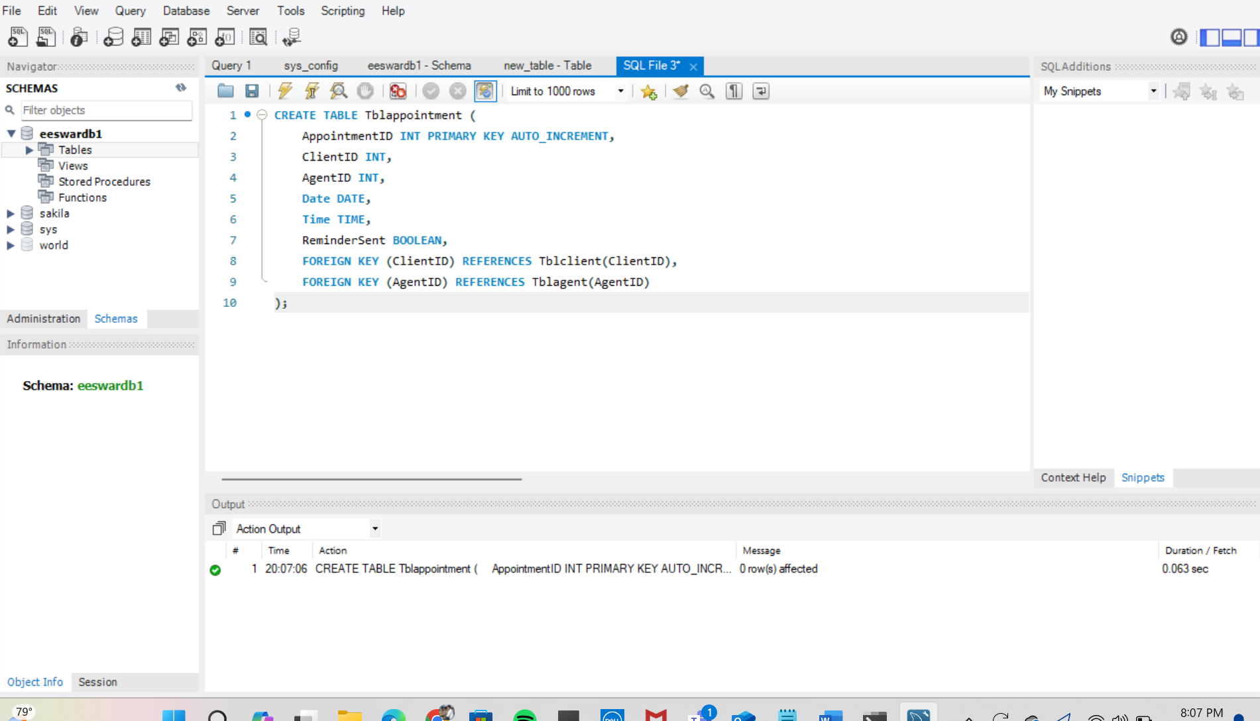

1. **Tblcomment Table**

The REMDBS database's "Tblcomment" table is where clients' or agents' remarks and suggestions regarding certain properties are kept.

* CommentID: A special number that is automatically added to each new remark.
* PropertyID: A foreign key that links to the PropertyID in the Tblproperty table and references the property that the comment is made about.
* AgentID: A foreign key that links to the AgentID in the Tblagent database and references the agent that left the comment.
* Comment: The text of the feedback or comment that was left.

Property management, marketing, and decision-making processes might benefit from the insights into client and agent viewpoints that this table offers by tracking comments made on different properties.

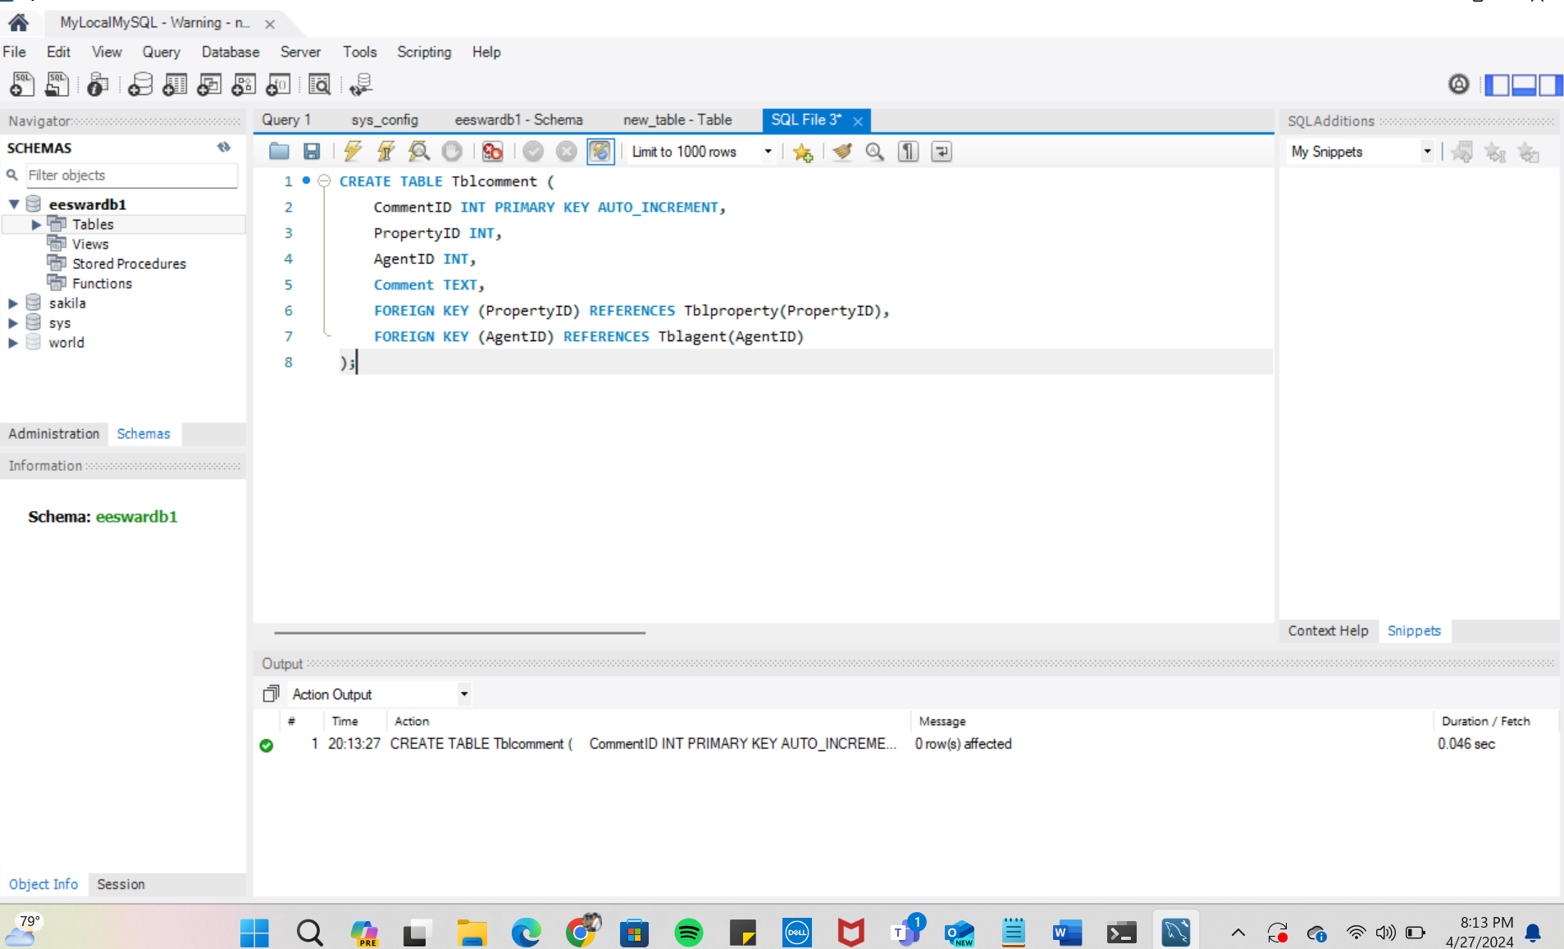

1. **Tblnotification Table**

* The REMDBS database's "Tblnotification" table is intended to hold system-generated notifications that alert users to different tasks, updates, and events.  
  NotificationID: An exclusive number that is automatically increased with every new entry for every notification.
* UserID: A foreign key that links to the AdminID in the Tbladmin table and references the user (admin) to whom the notification is intended.
* Type: Specifies the kind or class of notification, like alerts on new properties becoming up for sale, or comments.
* Content: Textual material that offers specifics or background about the notification.
* This table helps administrators stay informed about ongoing tasks, events, and activities inside the real estate management system by making it easier to communicate critical updates, reminders, and feedback to them.

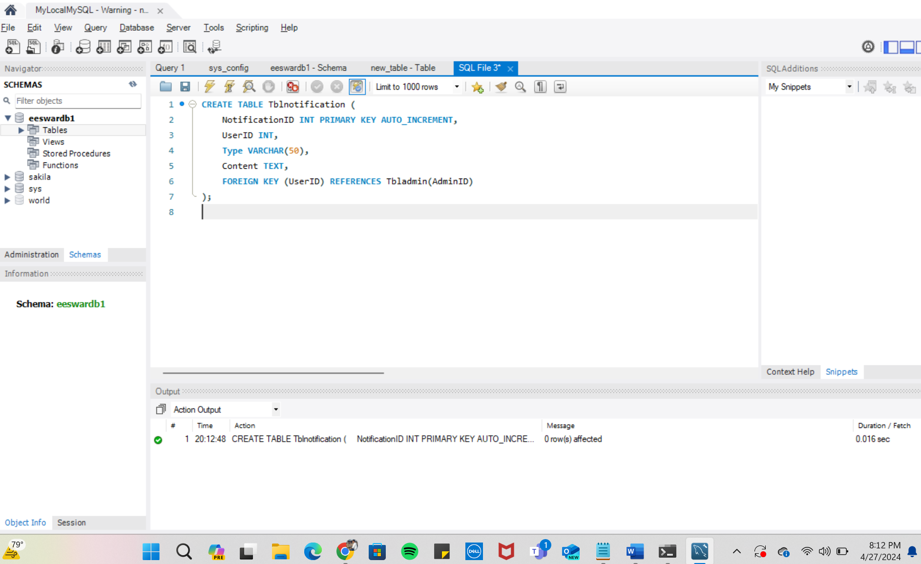

1. **Tblproperty Table**

The REMDBS "Tblproperty" database contains data regarding the different properties that are managed by the system. Here's a quick rundown of its objectives and structure:

* PropertyID: An automatically incrementing unique identifier for every new property entry.
* TypeID: Points to the TypeID in the Tblpropertytype table and indicates the kind of property (such as a flat, home or condo).
* Address: The property's address, encoded as a string that can include up to 255 characters.
* Price: The cost of the property, expressed to the nearest two decimal places and up to a maximum precision of ten digits.
* Size: An integer representing the property's square footage.

This table makes it easier to manage and keep track of different properties, including their sizes, types, addresses, and prices, making it possible for users to browse.

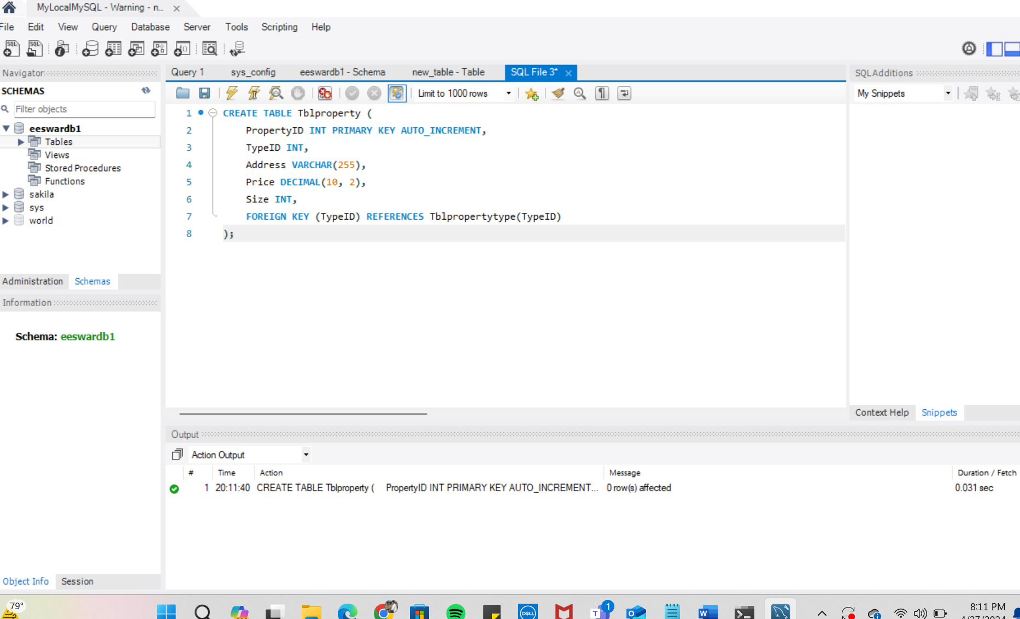

1. **Tblpropertytype Table**

Different property classification kinds are stored in the REMDBS "Tblpropertytype" table. This is a succinct summary of its objectives and structure:

* TypeID: A unique identifier for each property type entry that is automatically incremented.
* TypeName: This string, which can have a maximum length of 50 characters, describes the category or kind of property (for example, flat, home or flat).

This table facilitates easy classification and organisation within the real estate management system by serving as a reference for classifying properties according to different kinds.

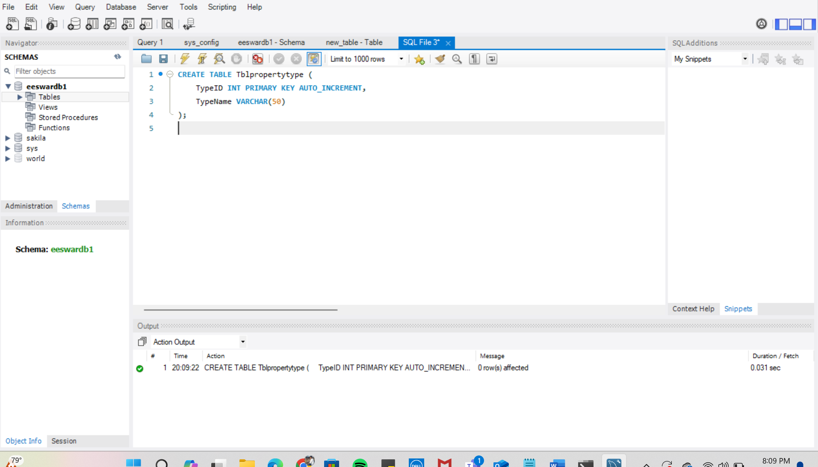

1. **Tblpropertyimage Table**

Images related to properties are kept in the "Tblpropertyimage" table in REMDBS. Here's a quick rundown of its composition and purpose:

* ImageID: A unique, automatically-incremented identifier for every image entry.
* PropertyID: Provides the ID of the property that the picture is associated with. By doing this, a connection is made between the property and the pictures that go with it.
* Image: This data type represents the actual image, which is kept as a Binary Large Object (BLOB) in storage.

In this method, URLs pointing to externally hosted photos are stored in place of the actual image data. Users can view visual representations of the properties listed in the real estate management system thanks to this table, which makes it easier for property photographs to be associated with their corresponding properties.

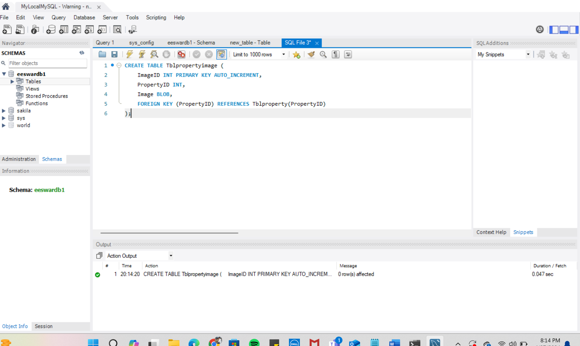

**Inserting Data into Tables**

1. **Insert into Tbladmin**

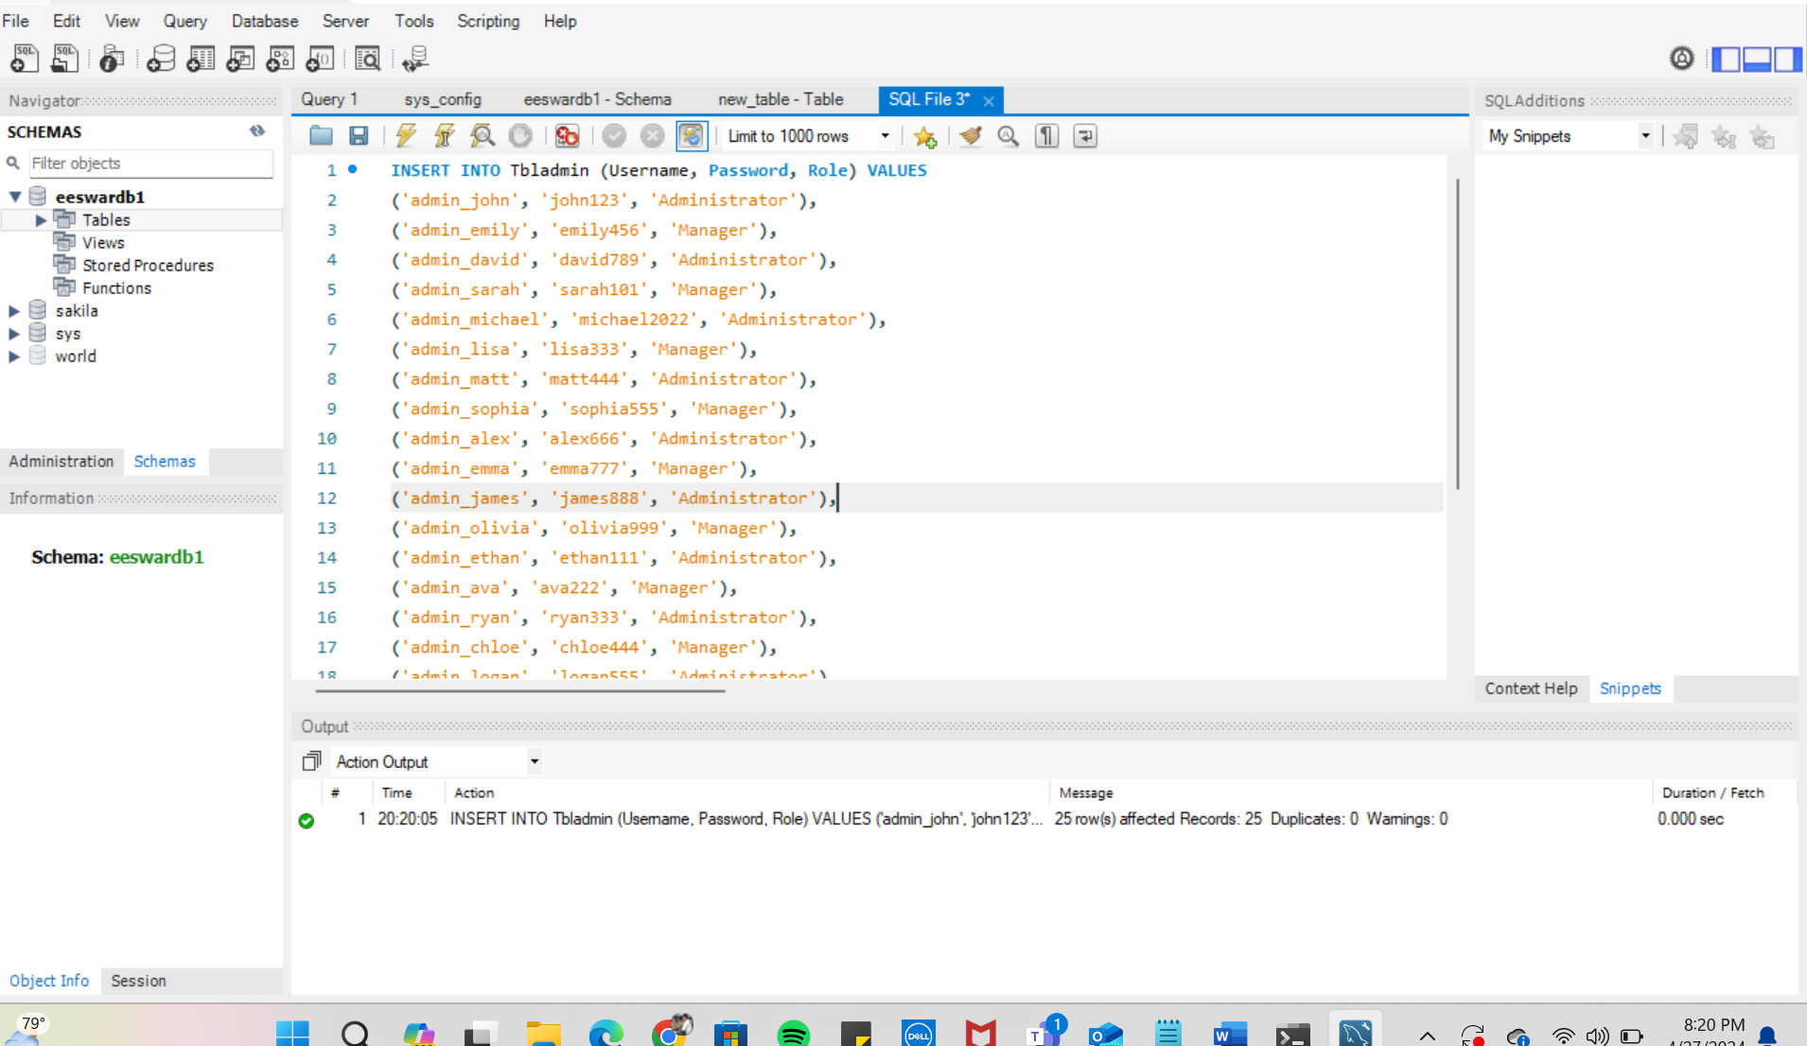

1. **Insert into Tblagent**

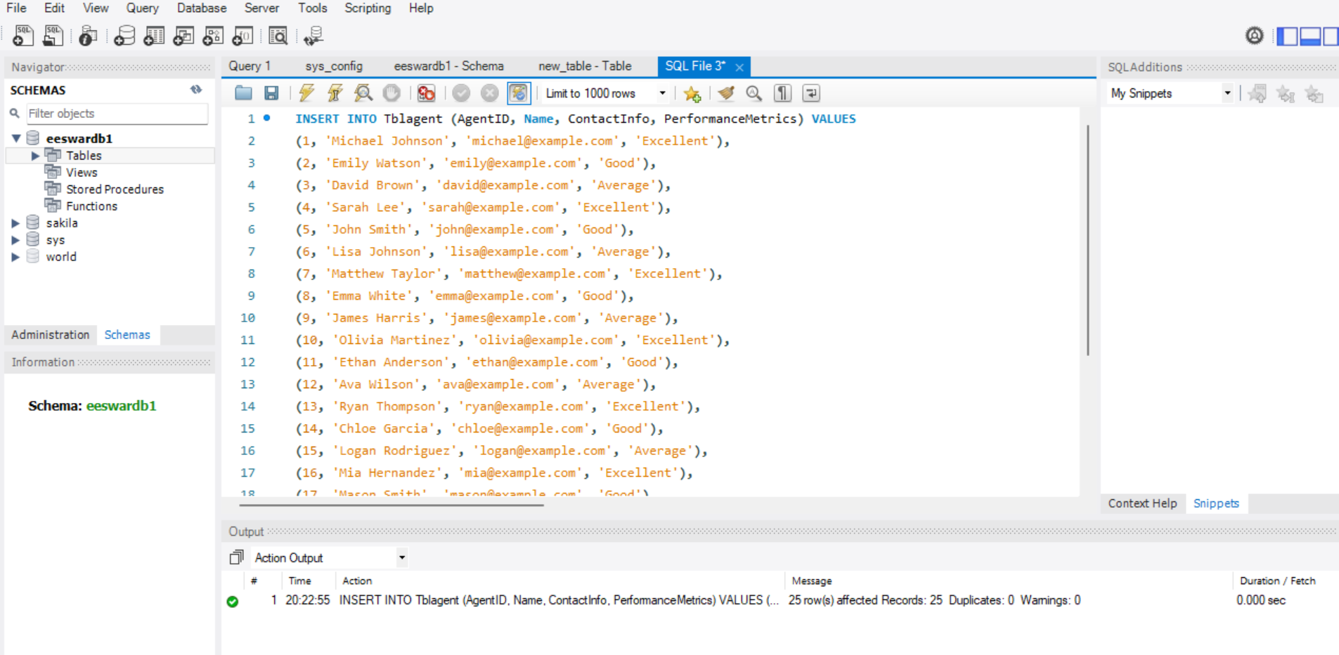

1. **Insert into Tblclient**

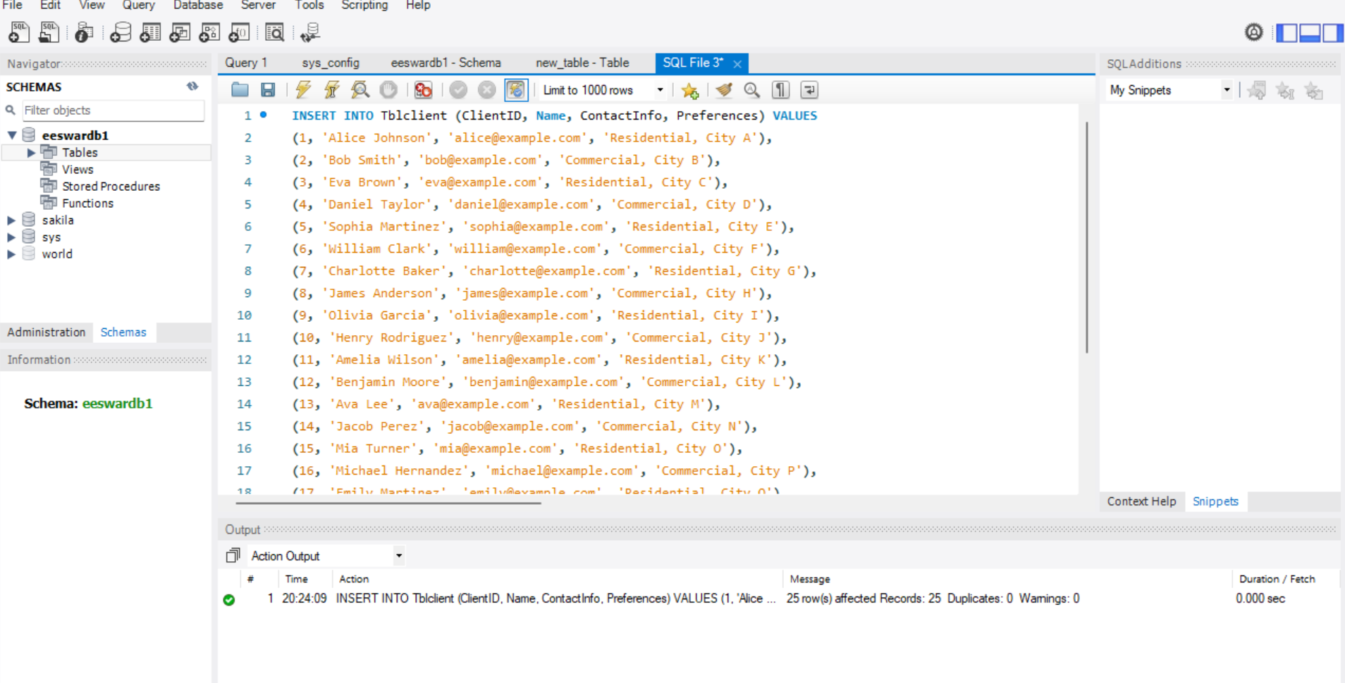

1. **Insert into Tblappointment**

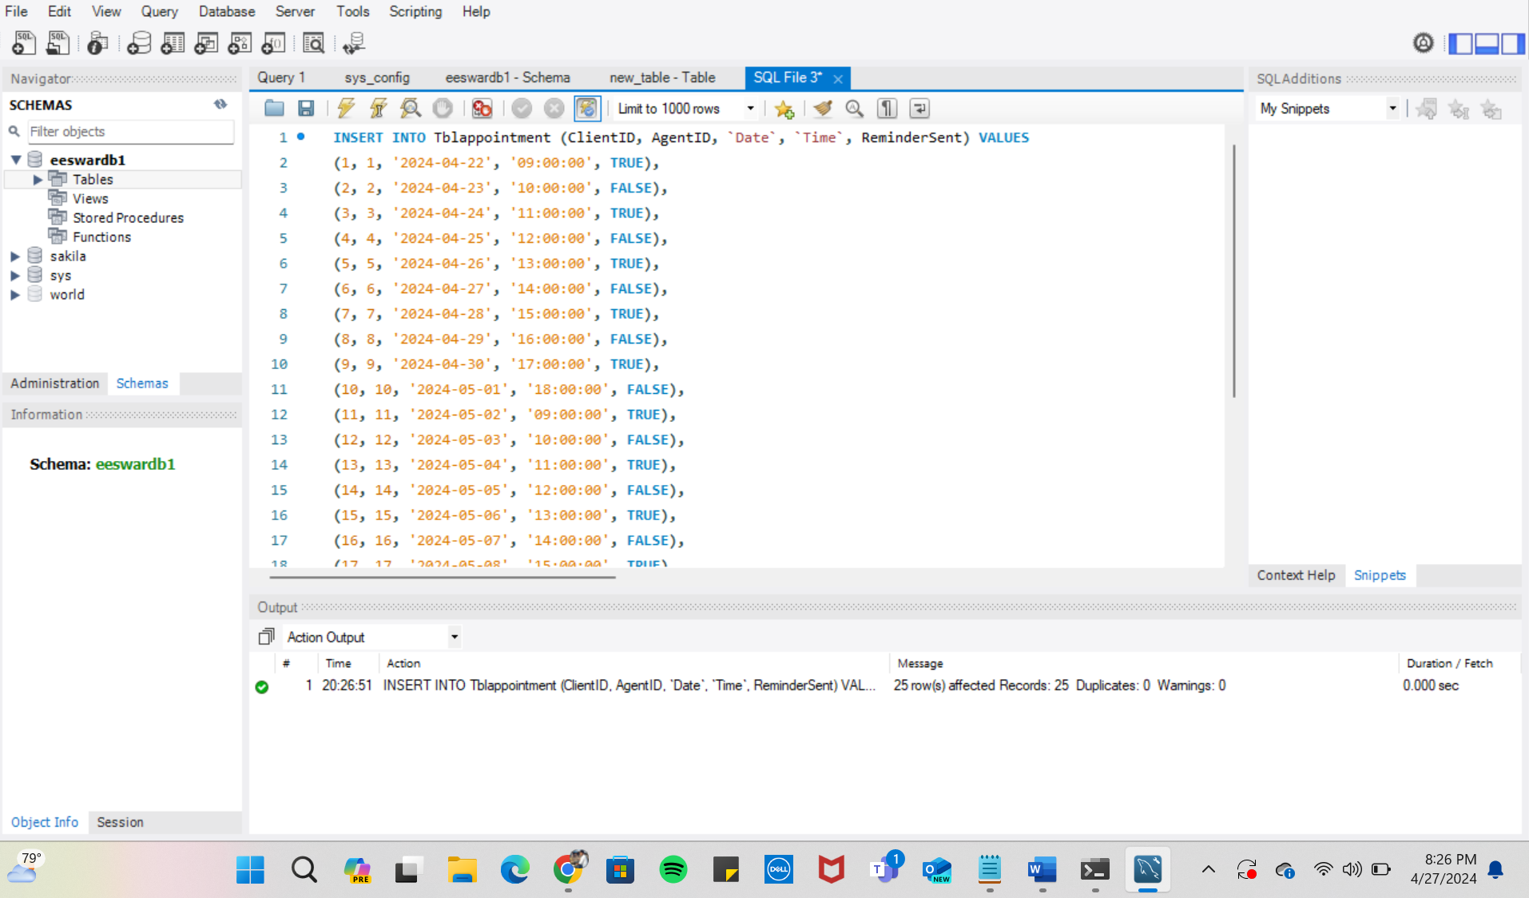

1. **Insert into Tblcomment**

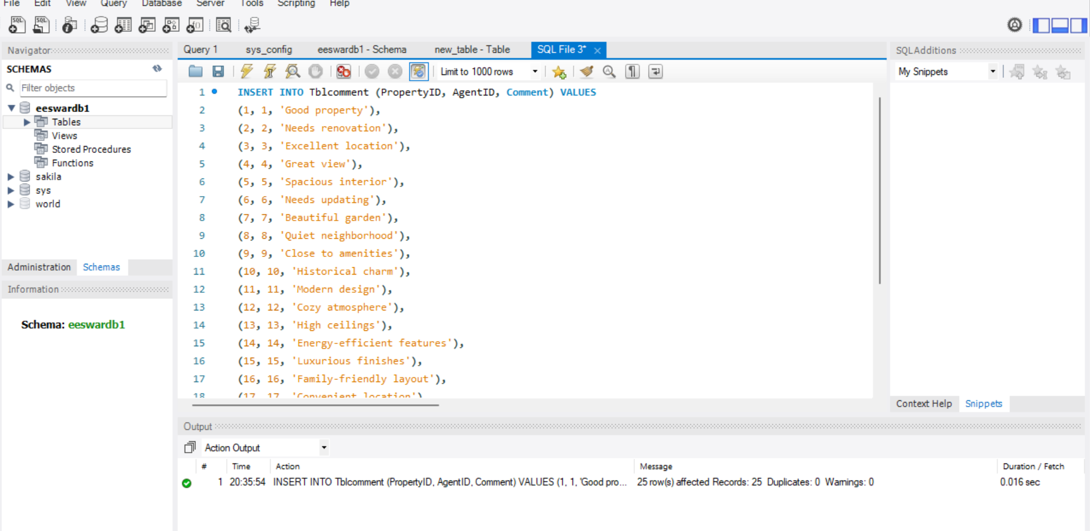

1. **Insert into Tblnotification**

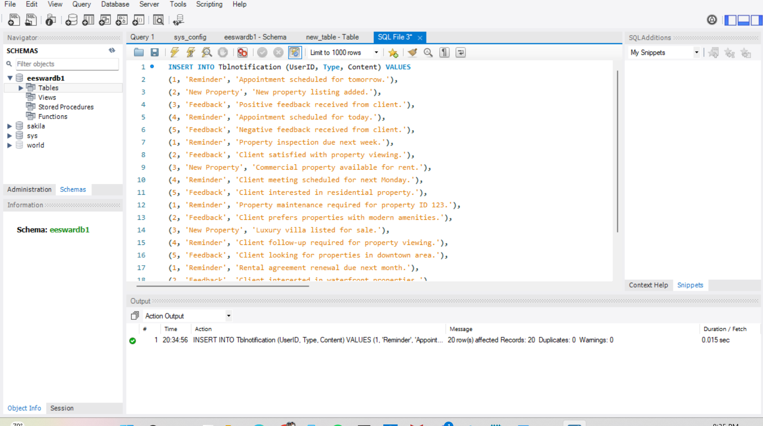

1. **Insert into Tblproperty**

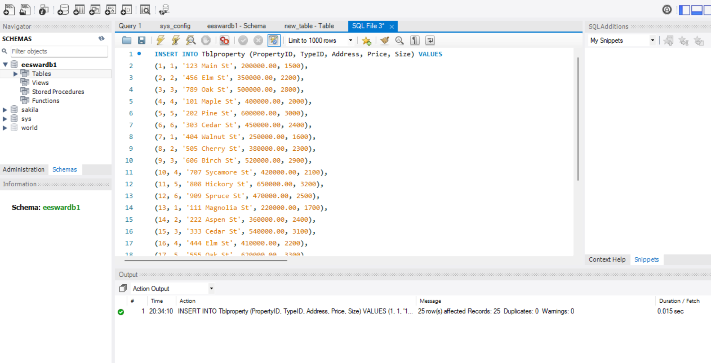

1. **Insert into Tblpropertytype**

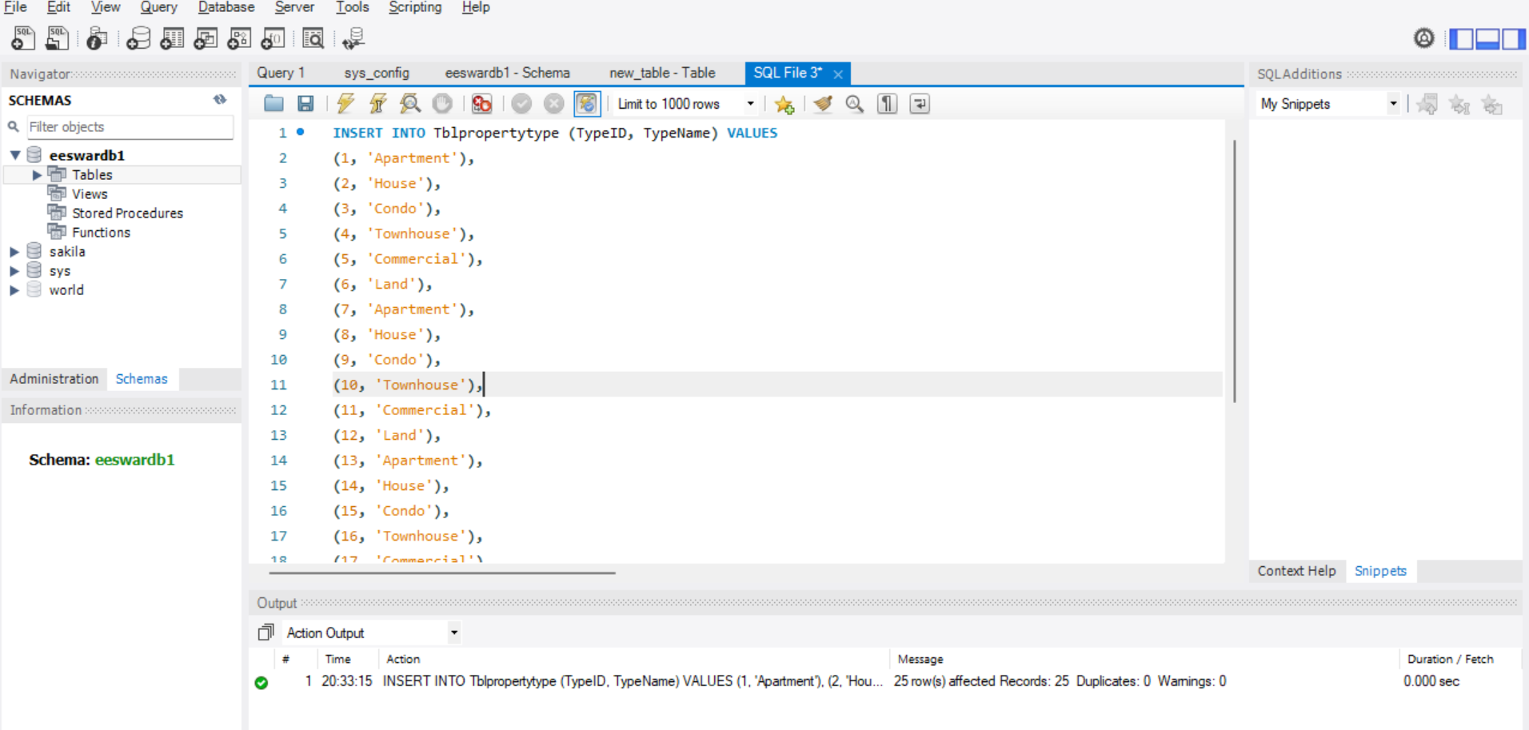

1. **Insert into Tblpropertyimage**

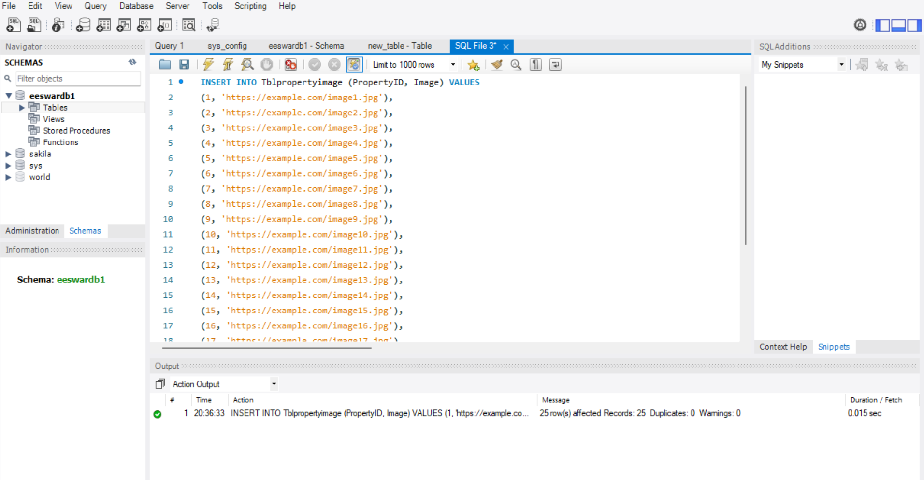

## Data Retrieval and Simple Reports

1. **For each type of property, determine the average size of the properties:**

SELECT TypeName, AVG(Size) AS AvgSize

FROM Tblproperty

INNER JOIN Tblpropertytype ON Tblproperty.TypeID = Tblpropertytype.TypeID

GROUP BY TypeName;

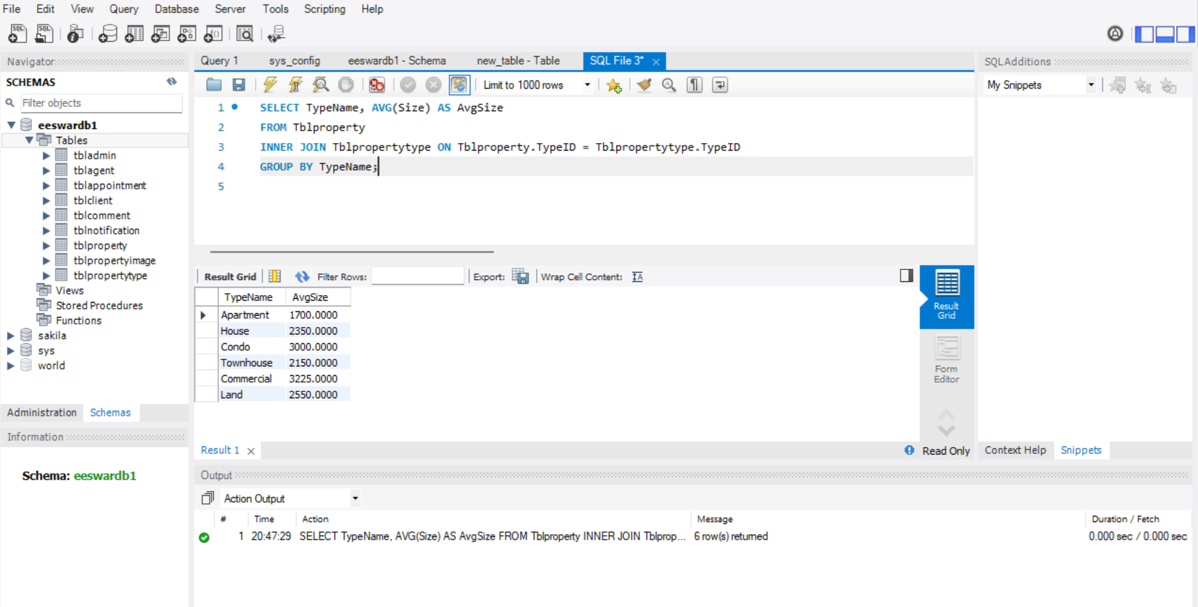

1. **List the properties and the agents' names that go with them:**

SELECT p.PropertyID, p.Address, p.Price, a.Name AS AgentName

FROM Tblproperty AS p

INNER JOIN Tblagent AS a ON p.PropertyID = a.AgentID;

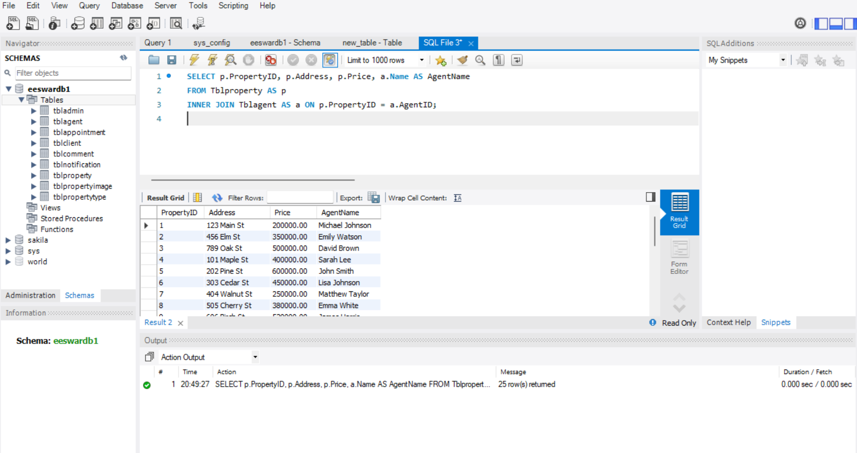

1. **Count the number of appointments scheduled for each agent:**

SELECT a.AgentID, a.Name AS AgentName, COUNT(*) AS AppointmentCount

FROM Tblagent AS a

LEFT JOIN Tblappointment AS app ON a.AgentID = app.AgentID

GROUP BY a.AgentID, a.Name;

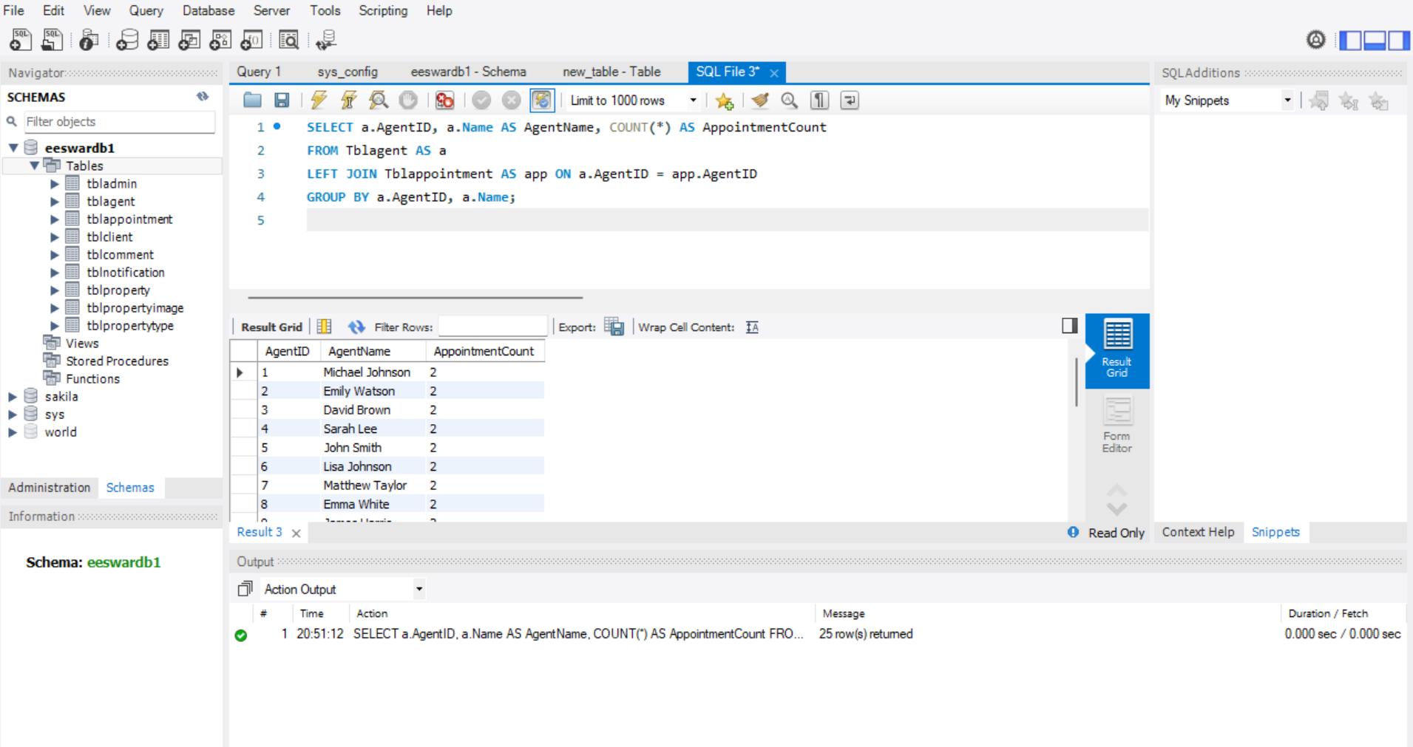

1. **Locate the agents who have scheduled the most appointments:**

SELECT a.AgentID, a.Name AS AgentName, COUNT(*) AS AppointmentCount

FROM Tblagent AS a

LEFT JOIN Tblappointment AS app ON a.AgentID = app.AgentID

GROUP BY a.AgentID, a.Name

ORDER BY AppointmentCount DESC

LIMIT 5;

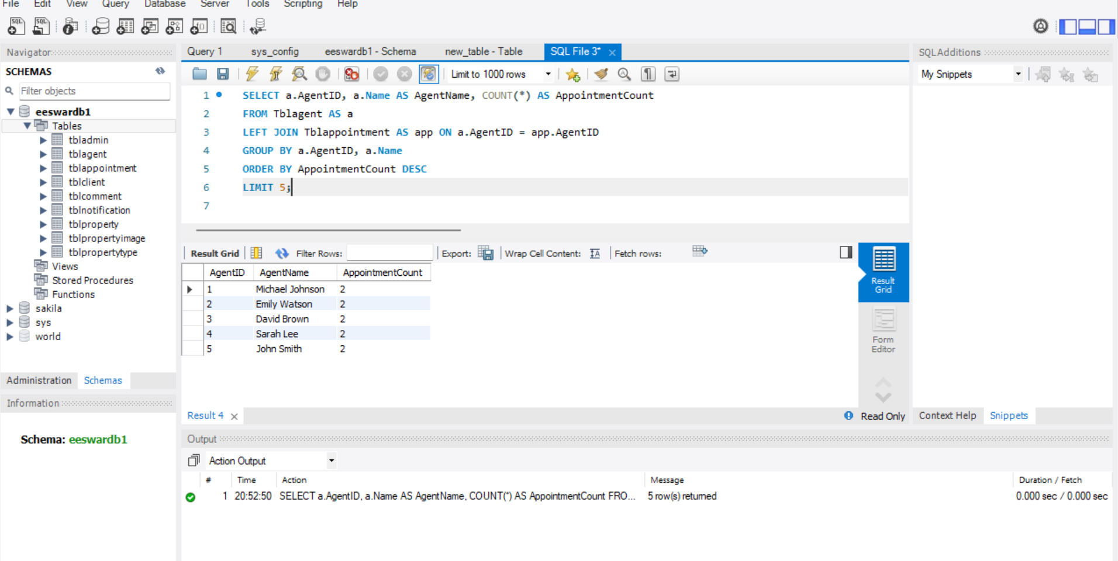

1. **Retrieve the clients who have appointments scheduled for tomorrow along with their corresponding agents:**

SELECT c.Name AS ClientName, c.ContactInfo AS ClientContact, a.Name AS AgentName, a.ContactInfo AS AgentContact

FROM Tblclient AS c

INNER JOIN Tblappointment AS app ON c.ClientID = app.ClientID

INNER JOIN Tblagent AS a ON app.AgentID = a.AgentID

WHERE app.Date = DATE_ADD(CURDATE(), INTERVAL 1 DAY);

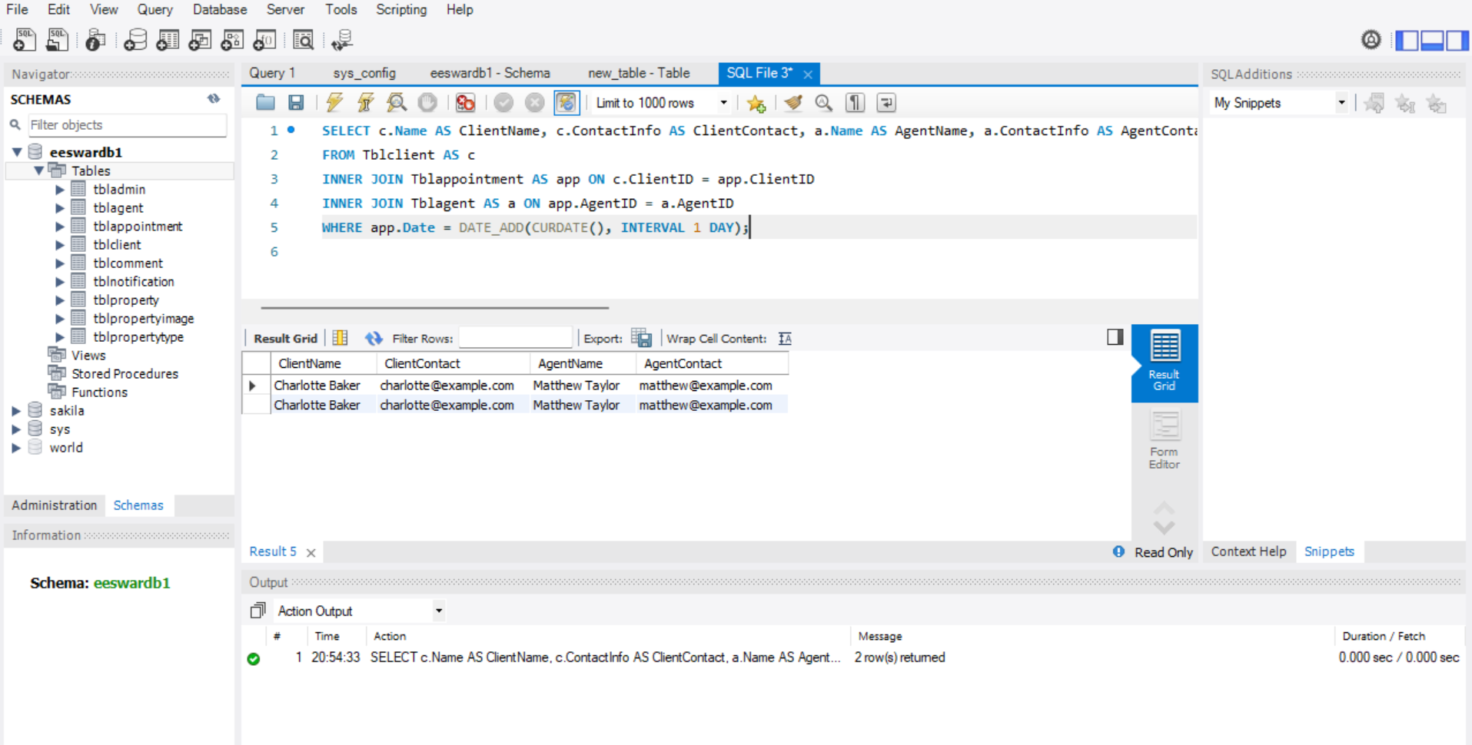

**Conclusion**

This project serves as an example of the Real Estate Management Database System (REMDBS). This system provides a comprehensive solution for real estate firms, property management firms, and private property owners. It encompasses a wide range of duties associated with running a real estate business, including financial administration, client interactions, property maintenance, rental agreement writing, and handling properties.

The user-friendly interface of REMDBS is complemented with an array of advanced features that make daily tasks easier to complete and boost output in general. By automating time-consuming tasks like maintaining clients, selling properties, setting up appointments, and sending notifications, REMDBS saves consumers time and effort. Users benefit from time and effort savings in addition to increased accuracy and efficiency.

The role-based access control system, which guarantees that users can only view and use the tools and information that are needed for their jobs, is one of the most significant features of REMDBS. Agents may focus on other duties, including listing properties and interacting with clients, because administrators can simply handle user accounts and permissions.

Furthermore, the system is outfitted with a change audit trail function that documents all system alterations and management actions for accountability and safety. This feature helps to safeguard the data's traceability and integrity, which eventually makes the system more dependable and trustworthy overall. When users have access to client management tools, they can keep thorough records of customer data, such as communication histories and preferences. Real estate brokers are able to: by recording the houses that their clients prefer and their feelings towards them, as well as by answering to their feedback.

Users are capable of managing meetings between agents and clients with ease by utilising options such as calendar integration and appointment scheduling. People find it simpler to keep their appointments when they receive automated reminders, which boosts customer satisfaction and professionalism.

Financial management solutions allow users to efficiently track and handle their real estate-related invoices, expenses, payments, the and rental agreements. Users gain valuable insight into the workings of the real estate sector by utilising specialised research and reporting tools, which helps them make more educated choices and perform better all around.

In conclusion, REMDBS offers a complete solution for the administration of investment properties and transactions that satisfies the demands of numerous real estate industry players. Enhancing interaction with stakeholders, operational efficiency, and overall performance of the organisation are the goals of the REMDBS system. It offers a clean interface for use, lots of great features, and an important focus on accountability and security.

# References

Big Data and its applications in smart real estate and the Disaster Management Life Cycle: A systematic analysis. (n.d.-a). <https://www.researchgate.net/publication/340182993_Big_Data_and_Its_Applications_in_Smart_Real_Estate_and_the_Disaster_Management_Life_Cycle_A_Systematic_Analysis>

potential role of geographic information systems in real estate industry-an overview. (n.d.-b). <https://www.researchgate.net/publication/284032269_Potential_Role_of_Geographic_Information_Systems_in_Real_Estate_Industry-An_Overview>

the present and future of the digital transformation of real estate: A systematic review of Smart Real Estate. (n.d.-c). <https://www.researchgate.net/publication/371956126_The_present_and_future_of_the_digital_transformation_of_real_estate_A_systematic_review_of_smart_real_estate>

the use of blockchain in real estate. (n.d.-d). <https://www.researchgate.net/publication/357049783_The_Use_of_Blockchain_in_Real_Estate>

Open access journals. MDPI. (n.d.). <https://www.mdpi.com/>